Professional Development: Engineering Education and Research vs Engineering Design
Speaker: Mr. Eugene Rutz
Date: Thursday, July 6th, 2017
Time: 11:00-12:00 PM
Venue: University of Cincinnati, Swift Hall, Room 516

Prepared by:
Ryan Wright, Ryle High School, Union, KY
RET Participant for Project #3: “Bio-inspired optimization of the travelling salesmen problem”
This session was given by Mr. Eugene Rutz on Thursday, July 6th from 11:00am-12:00pm at the University of Cincinnati in room 516 of Swift Hall. Eugene Rutz, MS, PE is an Academic Director in the College of Engineering & Applied Science at the University of Cincinnati. Eugene has oversight of the combined Bachelor's and Master's programs, the Master of Engineering programs and the collaborative program with regional high schools.
Mr. Rutz started the session with introductions. He went around the classroom and had each teacher give their name, subject, school, and the project that they are working on. He then went into what he did, talking about the programs he was involved in and some of the outreach programs he works with, and went over the talking points for the presentation (Fig 1). This led to a breakdown of what STEM really is and our thoughts on the issue. Teachers discussed how we tie it in to our classrooms in regards to curriculum and instructional design. We also discussed some of the places we get hung up on the components of STEM – for example, we think “technology” and our minds go straight to computers, when it means so much more than that.
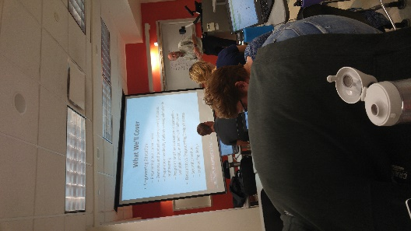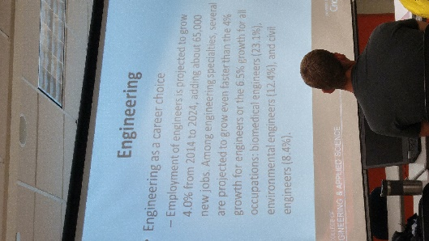
Figure 1. Introducing Talking Points Figure 2. Engineering Career Outlooks
Discussion then shifted towards engineering as a career choice. Mr. Rutz cited some specific numbers about the amount of careers that are out there (Fig 2)and what a graduate from an engineering program would have to look forward to. Careers in engineering (mostly) are growing at a fantastic rate so there is a large need for students in the field. He discussed the different engineering degrees offered at UC and which ones were easiest/hardest to place students into co-ops from. Mechanical engineering students are the easiest to place, while biomedical is the hardest. He then discussed which countries were producing the most students with engineering degrees, and emphasized that China is increasing at a much higher rate than in other countries. Discussion transitioned into where the jobs are located for engineering students, and why this is problematic in some cases.
Next, we talked about what a student needed to have in order to enter UC’s engineering program. Mr. Rutz stressed the importance of Algebra as being the most important math class for students pursuing an engineering career. H e also talked about how Calculus was a bit overrated as they’d have to take it again upon entering college anyways. Cost was also mentioned, as Mr. Rutz went over the financial requirements for someone interested in an engineering career. He provided information on scholarships and co-ops as well.
Finally, we got into the main topic of this seminar, which was engineering research vs engineering design. Mr. Rutz discussed some of the differences between the two, which was honestly kind of a rehash of some of our discussions from the first week of the RET program. Mr. Rutz especially stressed the importance of two things: the criteria and constraints aspects of engineering design, as it’s important that an engineer be able to work within a given set of parameters, and the open-endedness of engineering design versus the traditional scientific method.
Mr. Rutz ended his session by opening up the floor for questions from the audience.

